### Technical Design Document Template

1.0 Revision History

|  |  |
| --- | --- |
| Version | Description |
| 1.0 | Initial document |

2.0 Development Environment

2.1 Game Engine

Proprietary

2.2 IDE

Windows - Visual Studio 2022 Preview

Mac OS – Jetbrains CLion

2.3 Source Control procedures

All source will be available on [GitHub](https://github.com/lcomstive/AIE_AIForGames)

2.4 Third Party Libraries

[*Box2D*](https://box2d.org/)

[*Raylib*](https://raylib.com/)

[*Robin Hood Hashing*](https://github.com/martinus/robin-hood-hashing) (for faster unordered maps)

3.0 Game Overview

3.1 Technical Goals

- 2D animated graphics

- Stable 60 FPS on moderate hardware  
(recent-ish CPU, dedicated GPU)

- Consistent AI

3.2 Game Objects and Logic

- Animals (child of animated sprite object)

- Behaviour tree determines movement and actions

Subclasses:

- Predatory Animal (either carnivore or omnivore)

Will hunt other animals for food

- Passive Animal (either omnivore or herbivore)

Will avoid predatory animals and look for non-animal food sources

- Trees, rocks, and miscellaneous obstacles

- Pond (water source)

- Plants (food source for herbivores and omnivores)

- Carcasses (food source for carnivores. Replaces animals that have died)

3.3 Game Flow

User cannot interact with simulation.

4.0 Mechanics

NA

5.0 Graphics

Top-Down 2D, pixel art. Use spritesheets for animating and reducing amount of textures loaded

6.0 Artificial Intelligence

Behaviour Trees will be used to determine what action(s) to take.  
Creatures have intrinsic values such as hunger and thirst, as well as extrinsic senses such as sight (via viewcone combined with raycasting).

Behaviour Tree planning:

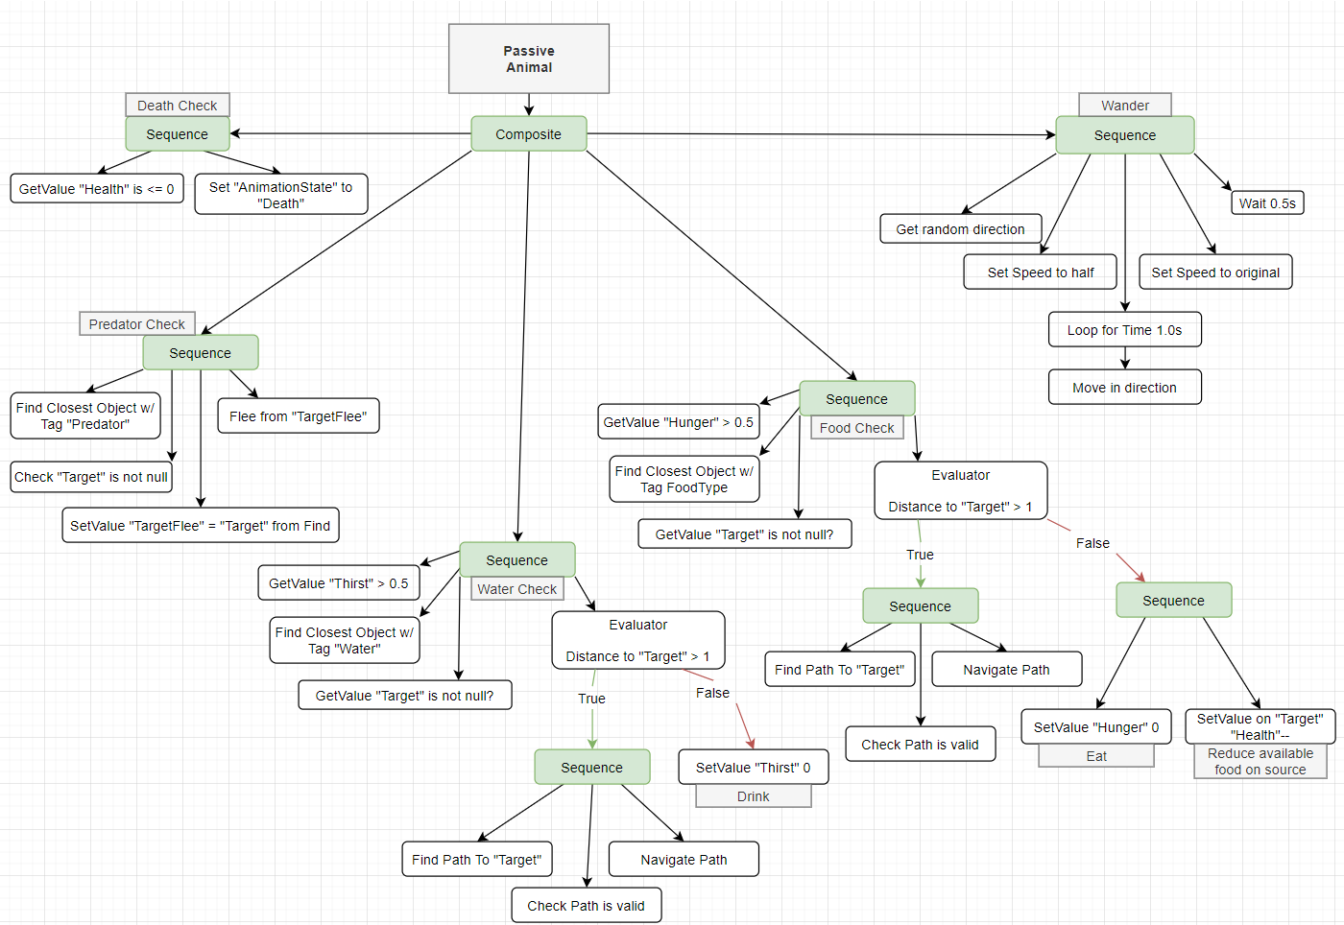

7.0 Physics

The Box2D open-source physics engine is used for colliders and raycasting.  
All colliders are boxes.

8.0 Items

NA

9.0 Game Flow

NA

10.0 Levels

NA

11.0 Interface

11.1 Menu

NA

11.2 Camera

Orthographic camera that moves around x & y axes

11.3 Controls

Camera moves around the scene with mouse while holding middle mouse button, zooms in and out using mousewheel.

Left mouse button spawns passive creature, right mouse button spawns predator.

14.0 Asset List

Sprites (32x32 or 16x16?)

16.0 Technical Risks